CHAPTER 3: Cells
Worksheet 3.4

Plant transport highways
Answers
Xylem tissue — a literacy exercise
1. Xylem tissue is an important conducting tissue in plants. The following statements are jumbled.
Your aim is to re-order these statements and remove repetitive words to create a brief paragraph (using as few sentences as possible) that describes the structure and function of xylem tissue.
Statements:
Lignin makes xylem tubes quite sturdy.
Water can move in only one direction in the xylem tubes.
Xylem tissue consists of long hollow tubes.
Xylem tissue carries water and minerals from the roots of plants.
Xylem tissue is made up of the remains of dead cells.
The cells of the xylem tubes have their cell walls strengthened with a woody substance called lignin.
Water moves through the xylem tubes from the roots to the leaves.
Water and minerals are required by all other parts of the plant.

Xylem tissue carries water and minerals, which are required by all parts of a plant, from the roots of plants (in one direction) towards the leaves. The xylem tissue consists of long hollow tubes that are the dead remains of cells that have been strengthened and made sturdy by a woody substance called lignin.

Phloem tissue — a cloze passage
2. Insert the appropriate words in the following cloze passage about phloem tissue in plants.
In green plants, phloem tissue transports sugar solutions ............... other parts of the plant.
The sugar ............... made by photosynthesis ............... leaf cells. Phloem tissue is made .................. of two types of cells: sieve cells and companion cells. Sieve cells, like xylem cells, arrange themselves end ............... end to form long tubes, but the cells that make up sieve tubes ............... still alive. They are called sieve cells because their cell walls ............. holes in them at each end of the tubular cells ............... allow solutions to move from one cell to another. Sugar solutions can move both up ............... down sieve tubes.
and
that
have
are
to
up
in
is
from
Vascular bundles in plant stems
3. Xylem and phloem tissue are located close together in vascular bundles in plant stems. Two vascular bundles are shown in a cross-section of a stem. Vascular bundles contain xylem tissue and phloem tissue separated by a narrow band of another type of tissues called cambium, which regenerates each tissue.
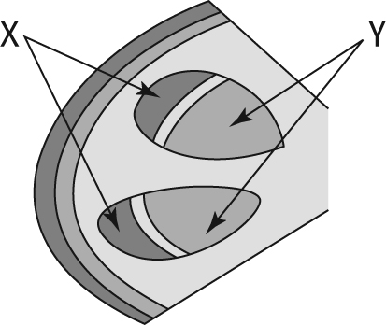  phloem | A student placed a plant shoot in some water coloured with red dye. He then cut a cross-section through the stem and observed it using a hand lens. He saw that the red dye had been taken up by the tissue labelled X. Which tissue (X or Y) is xylem tissue and which is phloem tissue?  xylem  X: Y:

